JS Advanced Final Exam

Problem 1. Music Site
Environment Specifics
Please, be aware that every JS environment may behave differently when executing code. Certain things that work in the browser are not supported in Node.js, which is the environment used by Judge.
The following actions are NOT supported:
- .forEach() with NodeList (returned by querySelector() and querySelectorAll())
- .forEach() with HTMLCollection (returned by getElementsByClassName() and element.children)
- Using the spread-operator (...) to convert a NodeList into an array
- append() in Judge (use only appendChild())
- replaceWith() in Judge
- replaceAll() in Judge
- closest() in Judge
- prepend()
- replaceChildren()
- Always turn the collection into a JS array (forEach, forOf, et.)
If you want to perform these operations, you may use Array.from() to first convert the collection into an array.
Use the provided skeleton to solve this problem.
Note: You can't and you have no permission to change directly the given HTML code (index.html file).
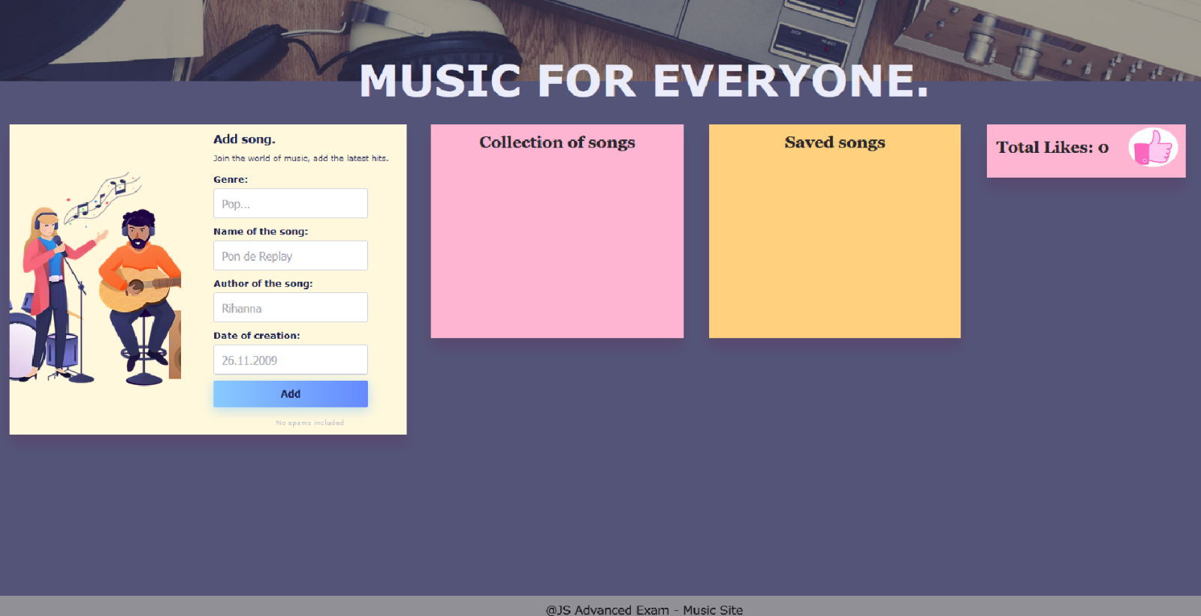

Your Task
Write the missing JavaScript code to make the Music Site work as expected:
- All fields (genre, name, author, and date) are filled with the correct input
  - Genre, name, author, and date are non-empty strings
- The program should not do anything if any of the input fields are empty.

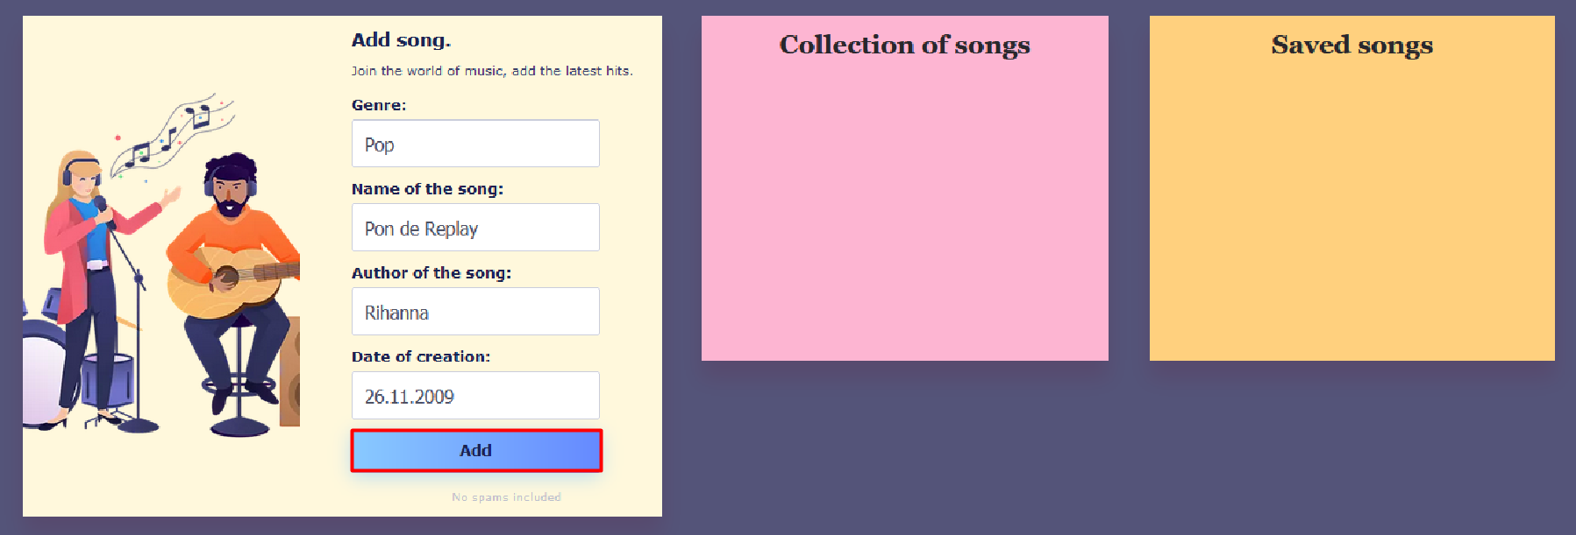
- Getting the information about a new song

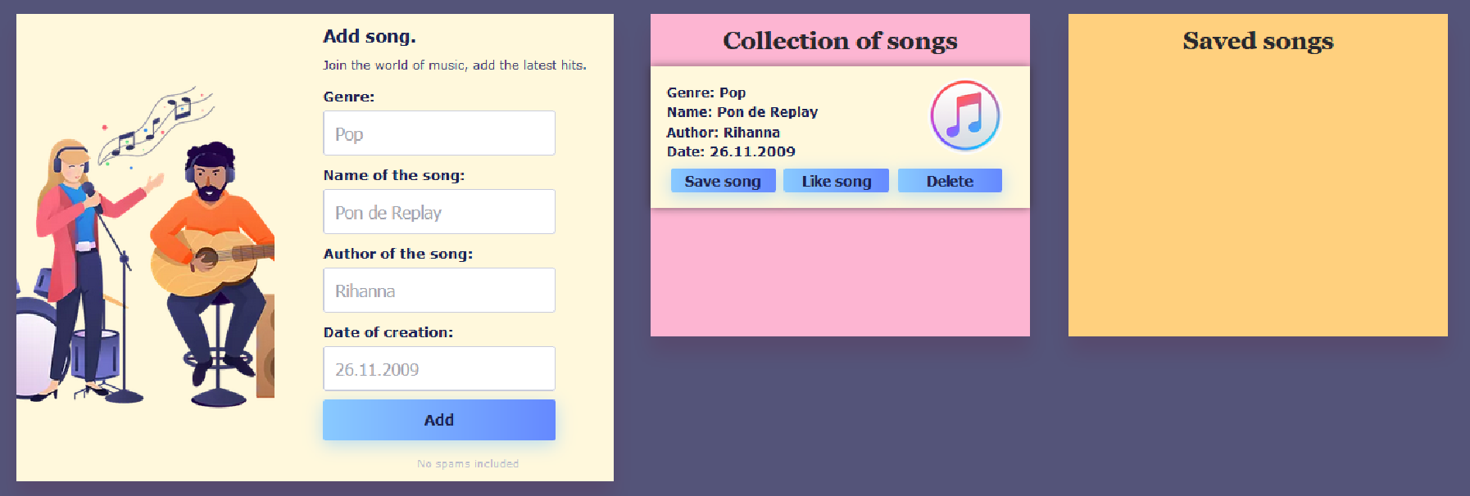
- When you click the ["Add"] button, the information from the input fields must be added to the div with the class "all-hits-container" and then clear input fields.

- The HTML structure looks like this:
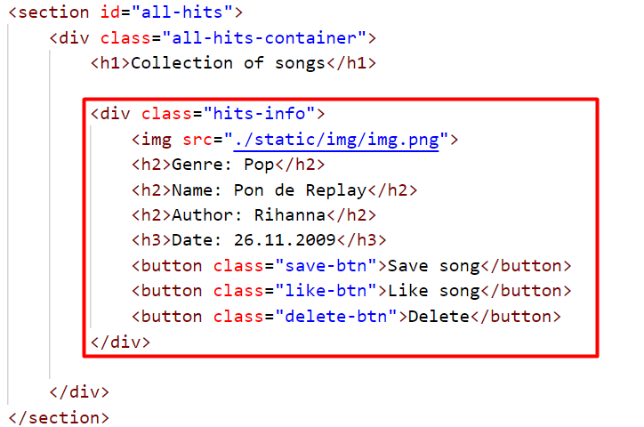

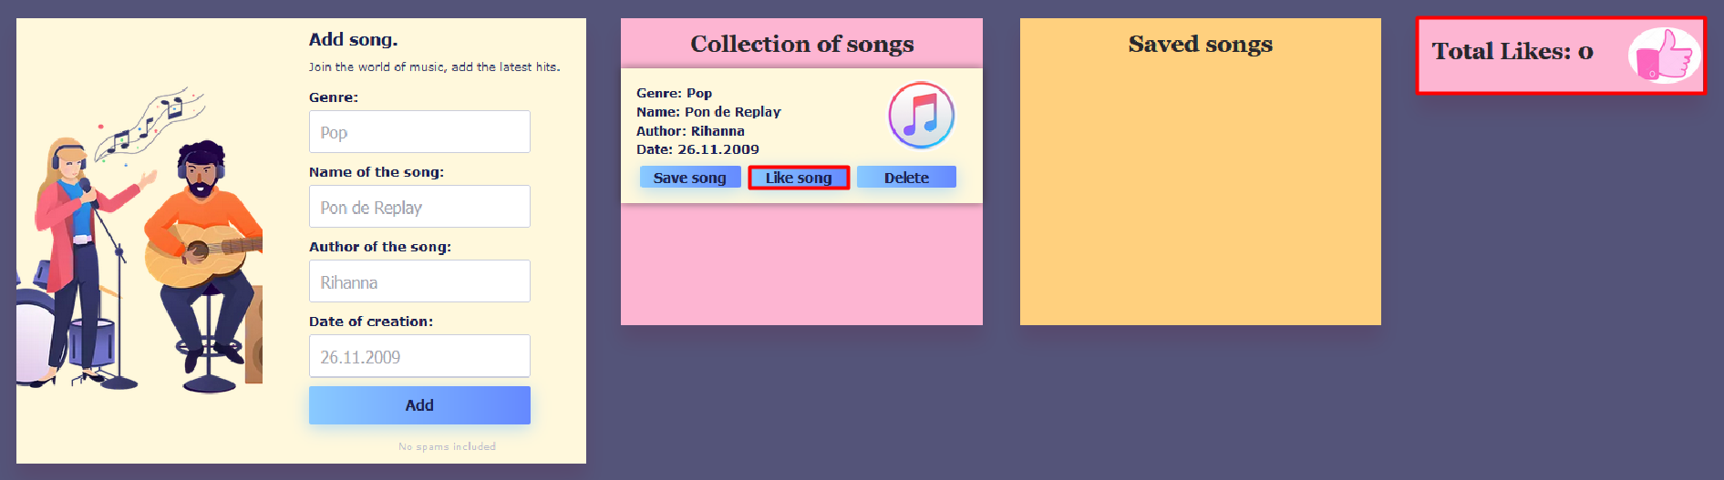
- When the ["Like song"] button is clicked:
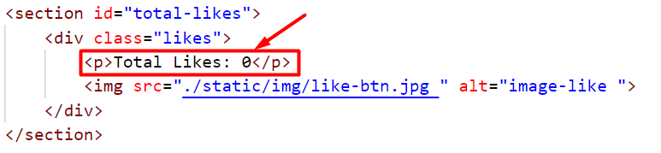
  - You need to take a value of the current number of likes inside the paragraph in the section with the id "total-likes" and increase the value by one.
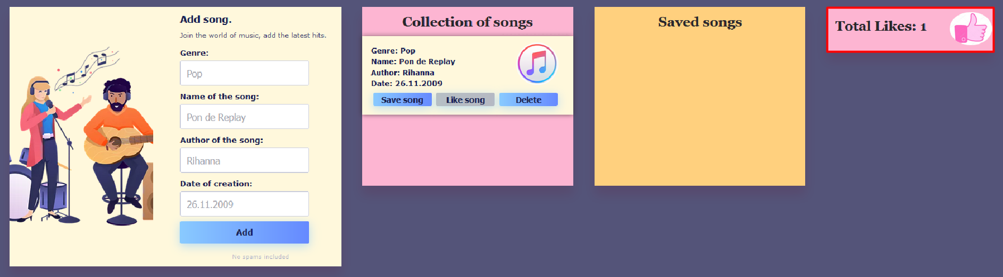
  - The button ["Like song"] for the current song must then be disabled, as the user has the right to like the song only once (Once the button is disabled, its color will turn gray).

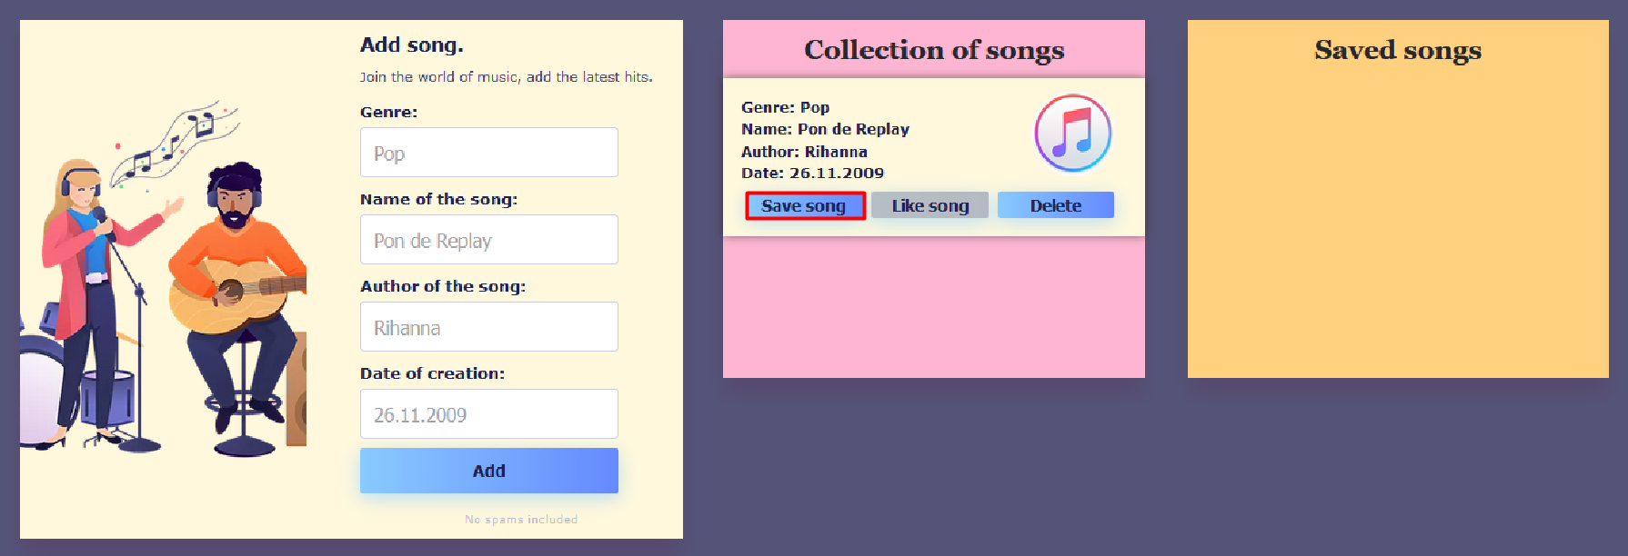
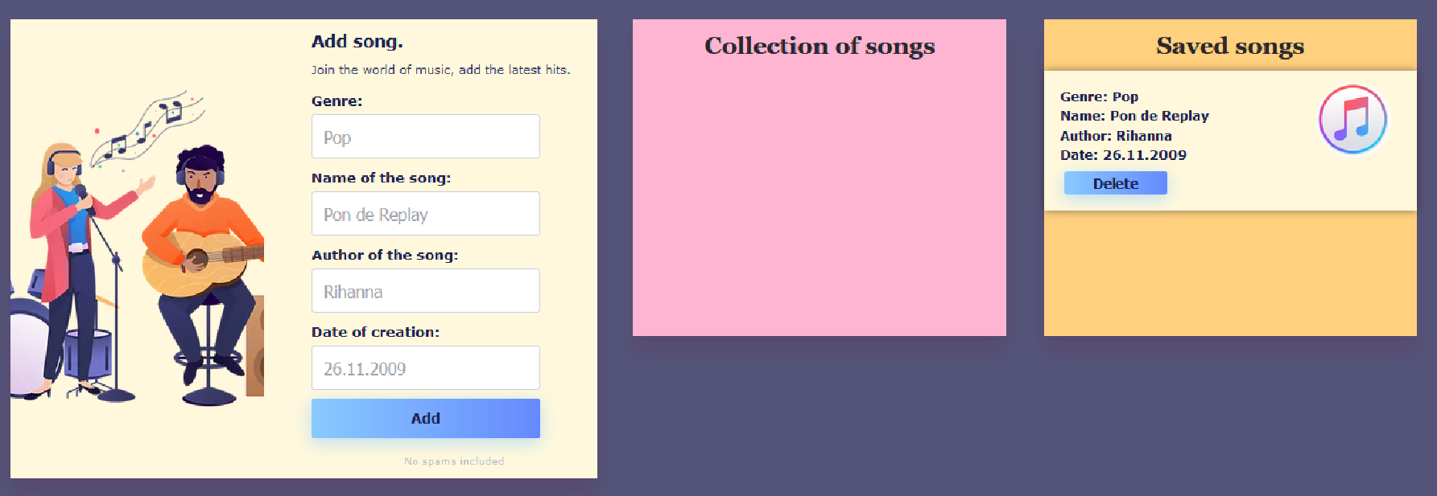
- When the ["Save song"] button is clicked, you need to move the current song in the div with class "saved-container".

- The HTML structure looks like this:
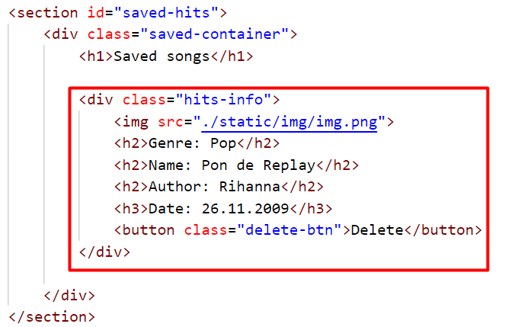

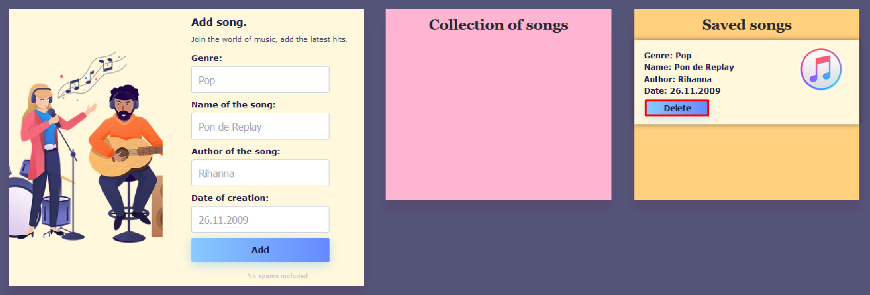
- When you click the ["Delete"] button, the song should be removed from the current section.
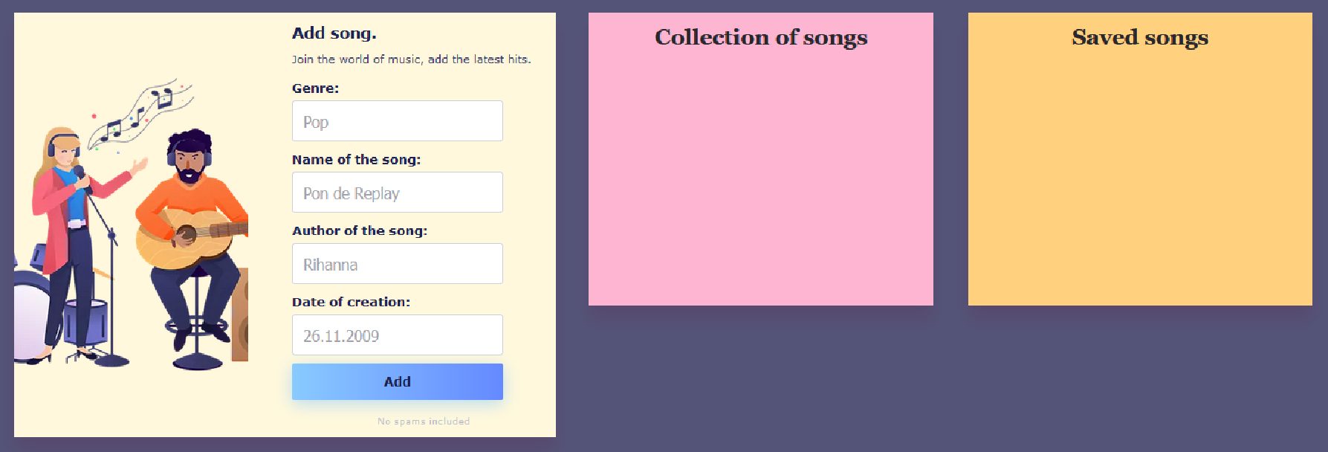
Note: When deleting a song, you should not reduce the value of the current number of likes.

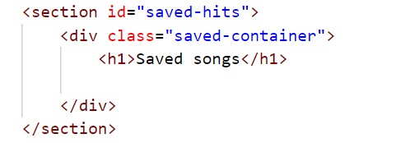
- The HTML structure looks like this:

Submission
Submit only your solve() function.

GOOD LUCK…

